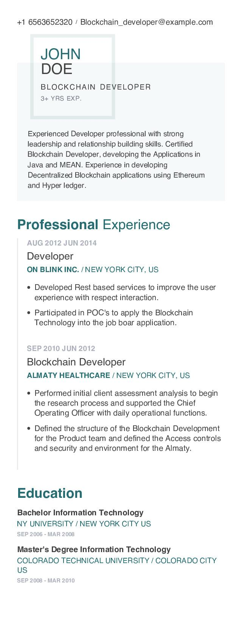
+1 6563652320 Blockchain_developer@example.com
JOHN DOE
BLOCKCHAIN DEVELOPER 3+ YRS EXP.
Experienced Developer professional with strong leadership and relationship building skills. Certified Blockchain Developer, developing the Applications in Java and MEAN. Experience in developing
Decentralized Blockchain applications using Ethereum and Hyper ledger.
Professional Experience
AUG 2012 JUN 2014
Developer
ON BLINK INC./NEW YORK CITY, US
• Developed Rest based services to improve the user experience with respect interaction.
• Participated in POC's to apply the Blockchain Technology into the job boar application.
SEP 2010 JUN 2012
Blockchain Developer
ALMATY HEALTHCARE / NEW YORK CITY, US
• Performed initial client assessment analysis to begin the research process and supported the Chief Operating Officer with daily operational functions.
• Defined the structure of the Blockchain Development for the Product team and defined the Access controls and security and environment for the Almaty.
Education
Bachelor Information Technology
NY UNIVERSITY / NEW YORK CITY US
SEP 2006 - MAR 2008
Master's Degree Information Technology
COLORADO TECHNICAL UNIVERSITY/COLORADO CITY US
SEP 2008 - MAR 2010

